Craters Guide. Made by [TGA]BlackHawk

This picture guide will maybe help the new guys who don't know how to play craters. This will show you how to build and defense on the blue base. The guide is made in single player.Convert round 20 wilds, then start charging land bridge, I usually made 2. Use one bridge to fill the part at your crater here:
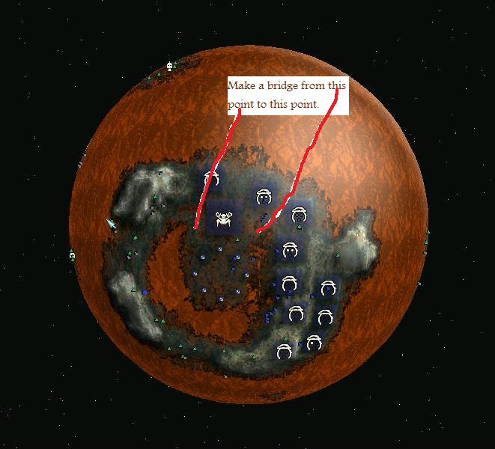

Then you use another Land bridge here:
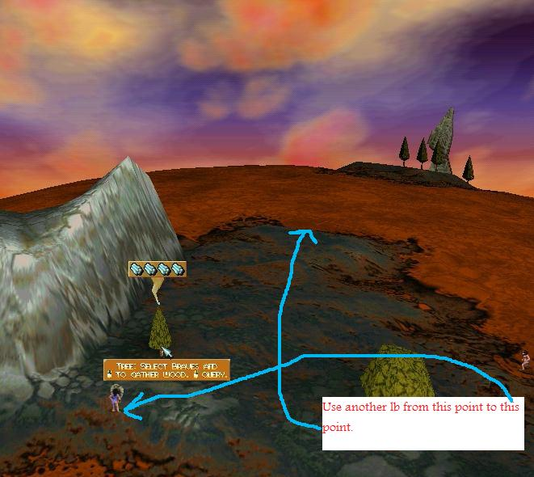
Your side defense should like this: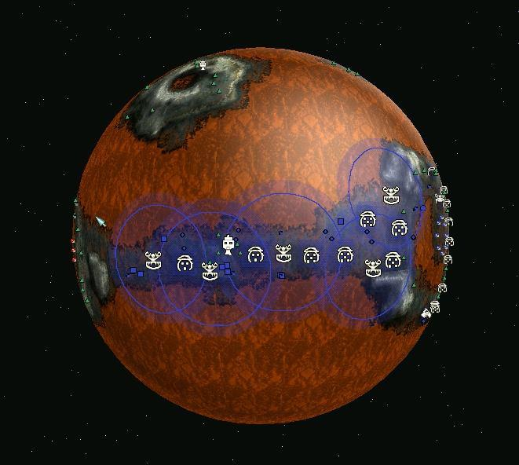
For more land you can fill the rest of your crater and your final base should look like this: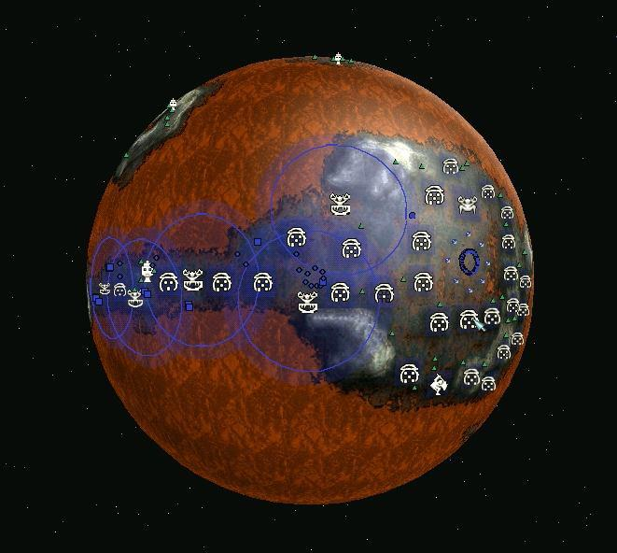
Made By [TGA]BlackHawk. All Rights Reserved to [TGA]BlackHawk

